- DB WITH NAME,DOB
AIM
To write a Prolog program to create a database containing Name and Date of Birth (DOB) and retrieve the required information using queries.
OBJECTIVE
- To create facts containing a person's name and DOB.
- To store the information in a Prolog database.
- To retrieve DOB using a person's name.
- To retrieve a person's name using their DOB.
ALGORITHM
- Start.
- Define the database using the predicate person(Name, DOB).
- Enter the name and DOB of different persons as facts.
- Use a query to retrieve the DOB for a given name.
- Use a query to retrieve the name for a given DOB.
- Display the result.
- Stop.
Flowchart:
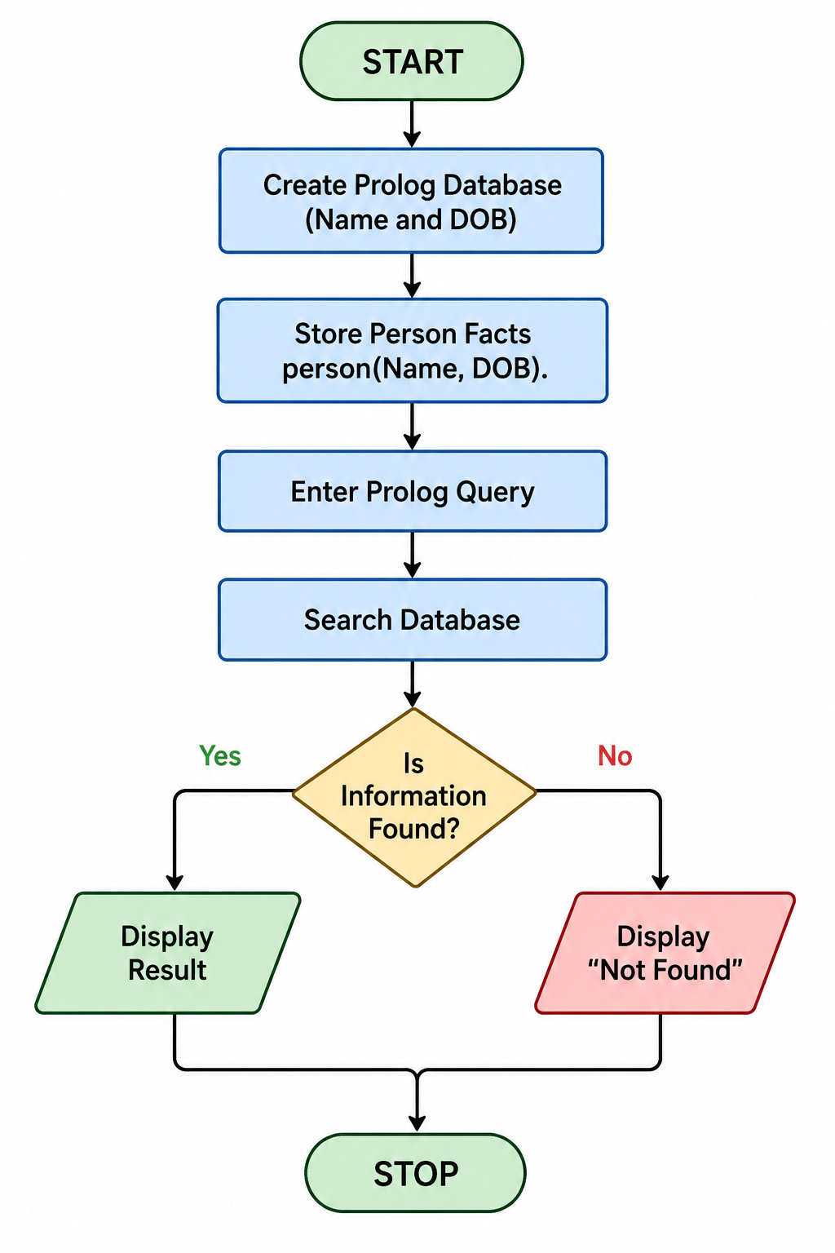
Code:
person(bhavya, '15-06-2005').
person(rahul, '20-08-2004').
person(priya, '10-12-2005').
person(akash, '25-03-2003').
person(anitha, '05-11-2004').
Output:
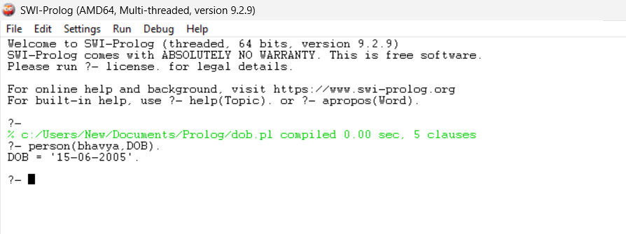
Result:
Thus, a Prolog database containing Name and DOB was successfully created, and the required information was retrieved using Prolog queries.

